M
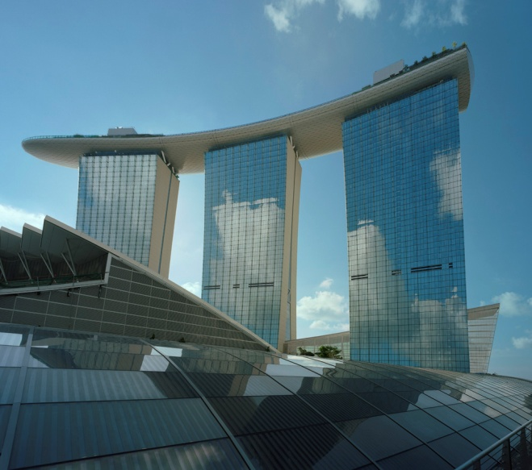
arina Bay Sands is an integrated resort fronting Marina Bay in Singapore. Developed by Las Vegas Sands (LVS), it is billed as the world's most expensive stand-alone casino property at US$ 5.7 billion, including the cost of the prime land. Marina Bay Sands is situated on 15.5 hectares of land with the gross floor area of 581,000 square metres. The iconic design has transformed Singapore's skyline and tourism landscape since it opened on 27 April 2010. The property has a hotel, convention and exhibition facilities, theatres, entertainment venues, retailers, and restaurants.
Las Vegas Sands initially committed to invest S$3.85 billion in the project, not including the fixed S$1.2 billion cost of the 6,000,000 square feet (560,000 m2) site itself. With the escalating costs of materials, such as sand and steel, and labour shortages owing to other major infrastructure and property development in the country, Sheldon Adelson placed the total cost of the development at S$8 billion as of July 2009.

Las Vegas Sands declared the undertaking as "one of the world's most challenging construction projects and certainly the
most expensive stand-alone integrated resort property ever built". It expects the casino to generate at least $1 billion in annual profit. Two months after the initial phased opening, the casino attracts around 25,000 visitors daily, about a third being Singaporeans and permanent residents who pay a $200 daily entry levy or $2,000 for annual unlimited access. Half a million gamblers passed through the casino in June 2010. In the third quarter of 2012, the revenues of the Marina Bay Sands fell almost 28 per cent from a year earlier.

For the economy, Marina Bay Sands is projected to stimulate an addition of $2.7 billion or 0.8% to Singapore's Gross Domestic Product by 2015, employing 10,000 people directly and 20,000 jobs being created in other industries.

Source: http://en.wikipedia.org/wiki/Marina_Bay_Sands

